**EXPLANATION OF ALGORITHM**

* I develoved a program using java to find difficulty of each question in MCQ (Quiz).
* First I initialized 10 strings q1,q2,q3, q4, q5, q6, q7, q8, q9, q10 as 10 questions. Each String have one questions.
* I created 10 new objects for class Question to have each question and its respective answer.
* I have a file **‘data.txt’** to store how many previous users answered that particular question correctly and total number users.
* **Storing of previous values is used to find difficulty of that particular question by using formula**
* **Avg=(anscorrect/total)**
* **IF avg>=0.75**

**SET diff= “Easy”**

* **ELSE IF avg>=0.40**

**SET diff= “Medium”**

* **ELSE**

**SET diff= “Hard”**

* Then I call takeTest() function to evaluate the answers
* Users must give answers only through **‘input.txt’.**
* I will get the input from **‘input.txt’** and previous correct answer for **‘data.txt’** using **‘Scanner’** class.
* For each correct answer given correctanswer of that particular question count is incremented in **‘datat.txt’** which is used to find difficulty of that particular question.
* After all the operation I used **‘FileWriter’** class to write the output in **‘output.txt’** and store the values in **‘data.txt’.**

**Some Screenshots of the program:**

**Getting input from Intput file :**

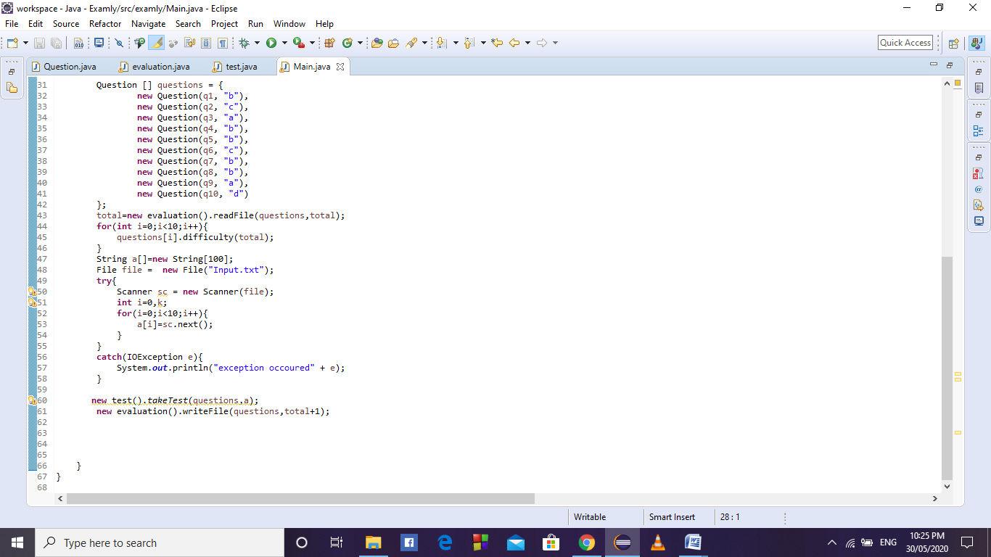

**Formula Calculation:**

